Homework Lesson 16 August 25

**Vocabulary**

Choose the vocabulary word from the box that best matches the picture.

|  |  |  |  |
| --- | --- | --- | --- |
| heather | intercultural | scenery | parliamentary |
| loch | referendum | tartan | kilt |

1. __________________. 2. ____________________

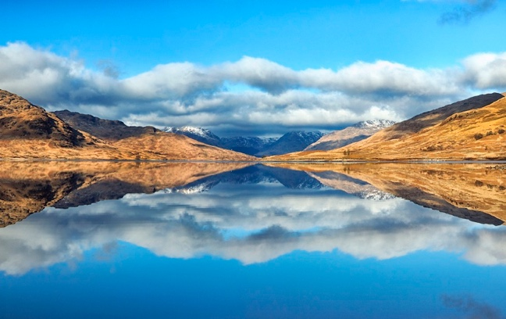

1. __________________ 4. ______________________

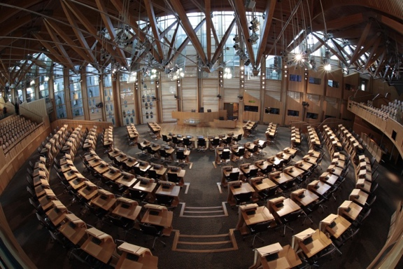

5. ____________________ 6. _____________________

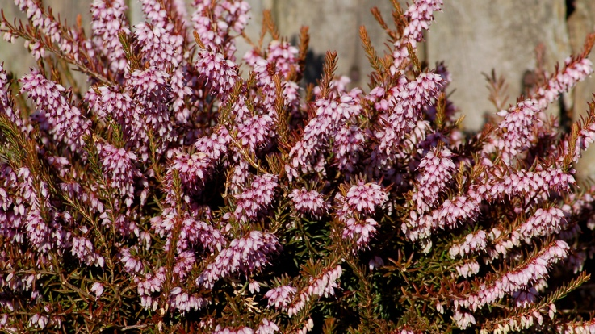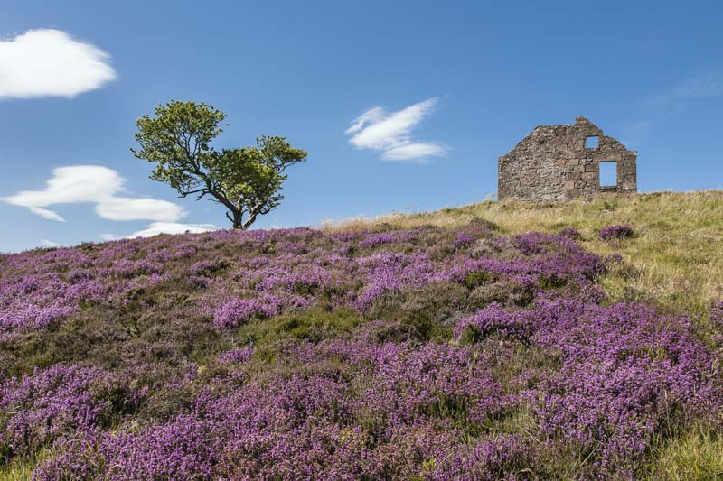

1. ___________________ 8. _____________________

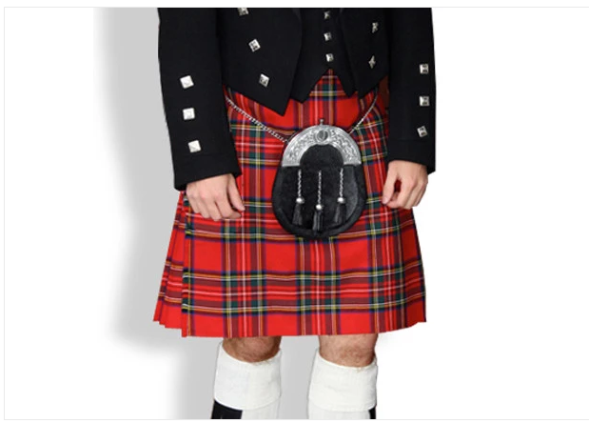

**Comprehension**

Answer the following T/F questions based on today’s reading

1. Only 20 of Scotland’s coastal island have people living on them. T/F
2. The most famous Loch in Scotland is Loch Ness. T/F
3. Glasgow is the capital of Scotland. T/F
4. The Edinburgh Festival is made up of a number of different festivals which happen at different times of the year. T/F
5. There are very few famous Scottish musicians. T/F
6. The first Scottish parliament was opened in 1999. T/F
7. In the 2014 referendum, Scotland voted to stay part of the UK. T/F
8. Scotland is building a name for itself in the computer games industry. T/F
9. Glasgow was named European City of culture in 2010.

**Discussion/Short Answer**

Read the following discussion questions from today’s lesson. After speaking about them in class, write your answers to the best of your ability. Try to use complete sentences.

1. Do you think it’s important to keep minority languages alive? Why / not?
2. Do you think that the growth of ‘English as an international language’ is helping to kill other languages?
3. Do you think that the world of technology is helping to kill languages?